The Willows Grow |& Achieve Curriculum
~ Physical Education ~
You plant your tiny precious seeds with us …
Together We Nurture, Enrich & help them Grow to be the best they can be!
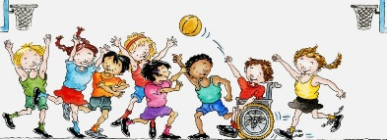
At The Willows school and EYC, we recognise the importance of physical education and the role it has to play in promoting long term, healthy lifestyles. We aim to deliver high-quality teaching and learning opportunities that inspire all children to succeed in physical activities. We want to teach children how to cooperate and collaborate with others, as part of a team, understanding fairness and equity of play to embed life-long values. PE at The Willows is an imperative element of the curriculum, which develops a need for healthy lifestyles, a balanced diet, positive growth mind-set and the resilience to persevere with activities that may be once have felt too difficult. Whether it takes the shape of activities outside during free flow, lessons in the classroom or PE sessions in the hall we want to strive to make each activity count in delivering high quality learning for the children.
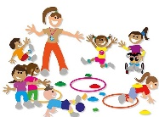

Teaching and Learning of PE at the Willows:
Pupils at The Willows participate in weekly high quality PE and sporting activities. There are also opportunities throughout the free flow continuous curriculum in the early years setting to enhance and develop children’s gross motor skills. Our PE programme incorporates a variety of sports to ensure all children develop the confidence, tolerance and the appreciation of their own and others’ strengths and weaknesses. We provide opportunities for all children to engage in extra-curricular activities throughout and beyond the school day, in addition to competitive sporting events. This is an inclusive approach which endeavours to encourage not only pupil’s physical development but also their well-being.
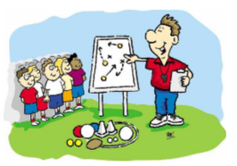
Our curriculum aims to improve the wellbeing and fitness of all children at The Willows, not only through the physical skills taught, but through the underpinning values and disciplines that PE promotes. We are able to see the impact of this through highly motivated and confident children; who are able to utilise these underpinning skills in an independent and effective way in order to live happy and healthy lives.

