The Willows Grow |& Achieve Curriculum
~ History ~
You plant your tiny precious seeds with us …
Together We Nurture, Enrich & help them Grow to be the best they can be!
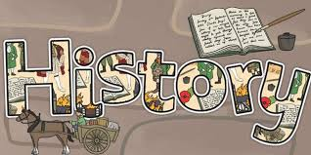
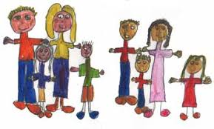
At the Willows School we believe that a high quality History education will help our children develop their knowledge and understanding of their own family history and the history within our local community. We aim for all our children to gain a coherent knowledge and understanding of Britain’s past and that of the wider world. We aim to inspire children’s curiosity to find out more about people and events from the past and equip them with the skills they need to ask questions and think critically; we want them to understand that we can learn so much from what has happened in the past and become “honest, active citizens” as they continue to grow and achieve now and in the future.

Teaching and Learning of History at the Willows:
The aims of both the EYFS and National Curriculum are fully embedded in all aspects of our History and wider Curriculum. Through our topic based curriculum we make relevant links to other subject areas including Geography and PSHE. In our nursery and reception classes children are taught History through the EYFS Curriculum as part of the strand “Understanding the World” and dimensions topics. Through our high quality language based curriculum and the opportunities available to children to learn through continuous provision; we encourage them to use their natural sense of wonder and curiosity to find out about the world around them. Children and adults share family events and celebrations together and we work closely with our community to ensure that children are given as many opportunities as possible to link their learning.

In KS1 our children continue to build upon the learning in EYFS and deepen their knowledge and understanding of how their lives and the local area have changed over time. We plan exciting opportunities to learn and discuss changes within their living memory and beyond through a range of topics. We aim for them to develop an understanding of chronology and ensure that we offer memorable events for them to embed new learning such as dressing up days, visitors and visits to bring historical learning alive. British Values are woven into everyday school life and values such as Respect and Tolerance are well embedded within our whole school community. Remembrance Day is an important and significant annual event planned for throughout the school.
