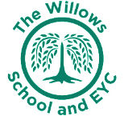
The Willows Grow |& Achieve Curriculum
~ Geography ~
You plant your tiny precious seeds with us …
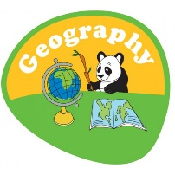
Together We Nurture, Enrich & help them Grow to be the best they can be!

At the Willows School we believe that a high quality Geography education will inspire pupils with a curiosity and fascination about the world around them. Our pupils will learn about their local environment, community as well as the wider world. Geography is taught through topics that are inspiring and aim to develop children’s natural curiosity. Our commitment for all children to have a language rich curriculum ensures that are successful in developing their skills in recognising, describing, explaining, comparing and evaluating human and physical geographical elements. We aim for our children to have empathy for how others live; to develop an awareness, respect and curiosity for different cultures and societies and the physical world around them and plan an annual Global week to ignite this learning. Children are given the opportunity to ask questions and make links, allowing them to make sense of the world around them and become “honest, active citizens” as they continue to grow and achieve now and in the future.
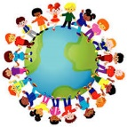

Teaching and Learning of Geography at the Willows:
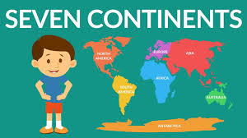
The aims of both the EYFS and National Curriculum are fully embedded in all aspects of our Geography and wider Curriculum. Through our topic based curriculum we make relevant links to other subject areas including math’s, computing and PSHE. In our nursery and reception classes children are taught Geography through the EYFS Curriculum as part of the strand “Understanding the World”. Through our high quality language based curriculum and the opportunities available to children to learn through continuous provision; we encourage them to use their natural sense of wonder and curiosity to find out about the world around them. We work closely with our community to ensure that children are given as many opportunities as possible to learn out in the local environment.

In KS1 our children continue to build upon the learning in EYFS and deepen their knowledge and understanding of the wider world. We plan exciting opportunities for children to learn and discuss new knowledge and geographical vocabulary and aim to make learning memorable with lots of opportunities for hands on, active learning. We encourage our children to ask questions and think critically about their local and wider environment and the impact humans have on the environment; and work hard to improve embed habits and beliefs that will impact their own future.
