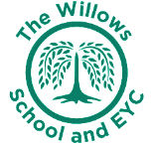
The Willows Grow |& Achieve Curriculum
~ Design Technology ~
You plant your tiny precious seeds with us …
Together We Nurture, Enrich & help them Grow to be the best they can be!
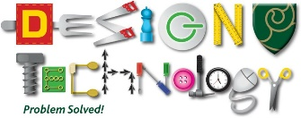

At the Willows School we believe that Design Technology is a vital part of education of all children. It is an engaging, creative and practical subject where we encourage our children to become successful problem solvers and work collaboratively with others. We aim to provide our children with a real life context for learning. We want to inspire and show our children the range of opportunities that are available for them in the wider world and therefore support them to make links in their learning and apply their new and prior knowledge and skills.
We aim to, wherever possible link DT projects to other subjects such as mathematics, science, computing and art.

Teaching and Learning of DT at the Willows:
The aims of both the EYFS and National Curriculum are fully embedded in our curriculum.
In our nursery and reception classes children are taught DT through the EYFS Curriculum as part of the strand “Expressive Arts and Design and Physical Development”. The children are empowered to use their imaginations and explore a range of media and materials through high quality continuous provision. The enabling environments, provision and adult teaching and scaffolding offer children autonomy to design, problem solve, create and evaluate.
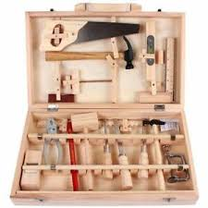
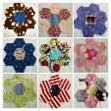

In KS1 our children continue to build upon their learning and begin to learn more about planning and designing as well as working with others. Our cross curricular approach to learning ensures that children are motivated and enthused with opportunities to research, represent their ideas, explore and investigate, develop their ideas, make a product and evaluate their work. Children will be exposed to a wide range of media including textiles, food and woodwork; through this, children will develop their skills, vocabulary and resilience

