The Willows Grow |& Achieve Curriculum
~ Computing ~
You plant your tiny precious seeds with us …
Together We Nurture, Enrich & help them Grow to be the best they can be!
At The Willows School & Early Years Centre we understand that our children are living in a world surrounded by devices and technology. Technology is changing the lives of everyone; through the teaching of computing we equip our children to participate in a rapidly changing world where work and leisure activities are increasingly transformed by technology. Our language rich curriculum aims for every child to become effective and confident communicators so that they can express themselves and share their knowledge and their ideas. At the Willows we believe that this is a vital skill and especially critical in keeping children safe when using IT. We encourage children to use key vocabulary as they learn new skills and support them in talking about how they keep themselves and others safe online. We use the Hectors World resources to support us in this.

Teaching and Learning of Computing at the Willows:
The aims of both the EYFS and National Curriculum are fully embedded in our curriculum.
In Early Years we encourage children to be involved with early programming, using technology/tablets effectively and interactive boards. The children will recognise that technology is used at home, school and all around them and will enjoy “Going on a technology hunt”. Through high quality continuous provision children are able to use Ipads to take photographs, videos and use QR codes to further their learning. Laptops, interactive whiteboards, controllable toys and other resources ensure that our children learn age appropriate computing skills.
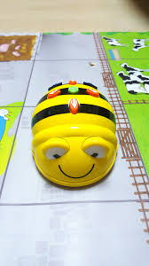
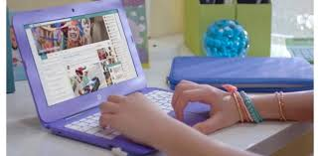
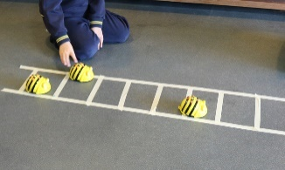

In KS1 our children continue to build upon their learning and begin to learn more about coding and programming. Our cross curricular approach to learning ensures that children are motivated and enthused to use computing to research, design and record their own learning. We teach e-safety as an explicit part of our curriculum through computing and RSE and PSHE.

