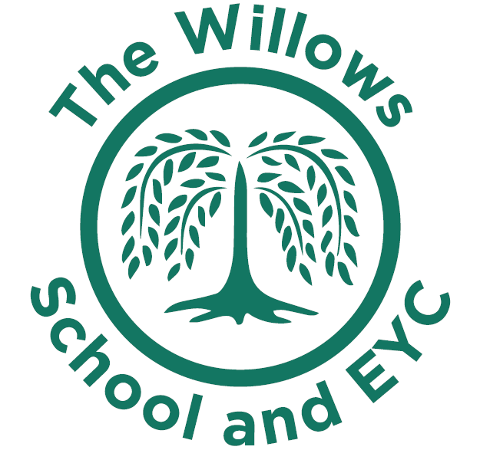

Curriculum Intent and Rationale

Introduction
The Willows School and Early Years Centre is situated in Milton Keynes. The school is located in the middle of a multi-cultural and diverse area close to the City centre.

Intent
While following the National Curriculum, we ensure our children enjoy their learning by giving them, where appropriate, the opportunity to be immersed in meaningful integrated units of work. Aiming to increase learner’s motivation, enthusiasm and engagement in their learning.

Our school promotes a real sense of vibrancy, nurture and is aspirational. This is very much the ethos of the school. It is something that we want to broaden and develop through our Learning Means the World curriculum. At The Willows School, we recognise the importance of human creativity and achievement and that this leads to the development of educated citizens. Thus, we want our curriculum to inspire and excite our pupils, whilst giving them the opportunities to learn skills for life and make connections between their learning and the wider world. The curriculum should be relevant, progressive, and inclusive building a sense of human flourishing. It will be a curriculum that meets the needs of our children and give both them and our staff a sense of empowerment. Our curriculum will ensure that our teachers feel a sense of pride in their teaching and our pupils in their learning.

Rationale for Implementation

Learning, enjoyment, development and achievement drives everything that we do. Our role, in partnership with parents, is to build the foundations for a successful education, to enable each child to fulfil every aspect of their potential and to encourage their growth into effective citizens, ready to play their part in the world and their community. We are a school that champions inclusivity and diversity, meaning at the heart of our ethos is a commitment to providing all children with the education they need to serve them throughout their lives
Underpinning our work is our mission:” To become honest active citizens and lifelong learners in a global society”.
We use Dimensions ‘Learning Means the World’ Curriculum as the main vehicle for achieving our outlined intent.

This curriculum is underpinned by four highly relevant world issues, known as the four Cs:-

Communication Culture Conflict Conservation

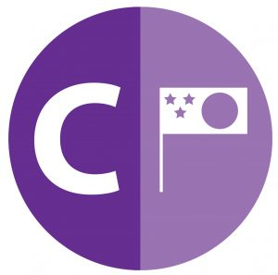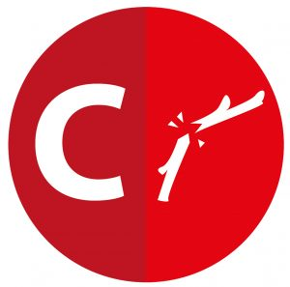

Communication
We believe communication is the root from which all other areas of the curriculum can grow and flourish. We are committed to nurturing and developing early language with our Nursery and EYFS pupils and seeing this progress throughout the school. Also, at The Willows School, we understand that exposure to positive language through role models and a wide selection of vocabulary can have a very positive effect on how our pupils’ communication skills will develop. We want our pupils to understand that communication is important in all aspects of life and how we communicate with one another both verbally and non-verbally is integral to building positive relationships and understanding the needs of others as well as ourselves.
We also want our pupils to recognise the impact online communication has on their lives both in school, at home and in the future.

Culture
As a multi-cultural school, culture is a very important aspect of our curriculum.
We want our pupils to fully appreciate and embrace cultural diversity. We intend, through our Learning Means the World curriculum, to enrich our pupils through music, art and various cultural traditions. We aim to ensure that our pupils respect our school values when exploring different cultures and recognise that having different opinions, views or ways of doing things is acceptable even if they do not necessarily agree with them. We aim to use communication skills significantly when discussing, debating and talking about culture. We also believe that we, as teachers must model this behaviour to our children.

Conflict
As adults, we have a responsibility to teach our pupils the skills they need to deal with everyday life. The world issue of Conflict will also have close links with our school values that our pupils show kindness when disagreeing with others. We aim to encourage our pupils to build a sense of global awareness where they consider the views of others before their own and understand that conflicts and disagreements aren’t always a bad thing but that they can lead to being able to understand one another better. We will also be building on our behaviour curriculum throughout our learning about conflict in terms of developing a sense of resilience and the idea of being restorative when it comes to managing personal conflicts. At The Willows School, beginning from the early years, our pupils are taught about self-regulation and providing them with the tools to deal with conflict whilst keeping safe.

Conservation
The benefit of having a large amount of outside space is that we can use it to significantly build on our learning about conservation. Through our curriculum, we want to encourage more use of our allotment space. We recognise the impact time outdoors can have on children and we want to use our outside space and conservation curriculum to support all our children but particularly those who require more physical and mental health support.
At The Willows School, we will also use the curriculum to learn about more modern conservation issues. We want to instil in our pupils a clear attitude to looking after things and knowing that if they want to experience beautiful things then they must make sure that they look after and take care of them, both inside and outside of the classroom. Our school council will take more responsibility to promote conservation in school by organising local events e.g. litter picking, designing posters, building good relationships with the elderly and also by developing more of an awareness of local problems.

Our curriculum narrative begins with Communication, as this will allow us to deeply embed our expectations and rules for the coming year. We recognise the importance of modelling clear and effective communication skills early and that the idea of language underpins every other part of the curriculum. We will then follow this with Culture. The clear language demonstration and instilling of the rules and values of our school will allow us to build on our school culture and start to explore the idea of cultures beyond our school and village.
Our third world issue will be Conflict. As the horizons of our pupils start to broaden, we can introduce the concepts of how conflicts occur, and they should now be able to utilise their improved communication skills to reflect on their own conflicts. Finally, we will complete our year with Conservation as we feel this is one of our strengths and it will allow us to build on enrichment and create a real sense of purpose in our learning throughout the year.

We also encourage our pupils to have high aspirations by teaching them about human creativity and achievement through additional Competency Units about famous figures and groups of people that focus on Creativity, Commitment, Courage and Community.

