**Looking after yourself and others**

**Who has mental health?**

We all have mental health – some people call this emotional health or wellbeing

**What is mental health?**

Mental health is a state of wellbeing in which every individual achieves their potential, copies with normal stresses of life, works productively and is able to contribute to their community. It affects how we think, feel and act.

Good mental health and wellbeing is just as important as good physical health. Like physical health, mental health can range across a spectrum from healthy to unwell; it can change on a day-to-day basis or over time.

## ****What if my child is experiencing difficulties with their mental health and wellbeing?****

Mental health doesn’t mean being happy all the time and neither does it mean avoiding stresses altogether. One of the most important ways to help your child is to listen to them and take their feelings seriously

If you are ever worried about your child’s mental health and wellbeing then, just as you would about any concerns that you have about their learning, come and talk to us.

This page also highlights people and places you can access support with outside of school.

**Look after yourself:**

If things are getting you down, it’s important to recognise this. Talk to someone you trust and see what they think. It is easy to go on struggling with very difficult situations because you feel that you should be able to cope and don’t deserve any help.

Go to your GP if things are really getting on top of you. Asking for some support from your doctor or a referral to a counselling service is a sign of strength. You can’t help your child if you are not being supported yourself.

**Mental Health Support Team:**

The Mental Health Support Teams (MHSTs) are an early intervention service who work in partnership with local schools to offer a whole school approach to mental health and wellbeing.

This is a service that supports children and young people, aged 5 to 18, and their families, with mild to moderate mental health difficulties. This includes anxiety and/or depression needs

MHSTs work with children and young people, parents/carers, school staff, and external specialist services. They provide support through:

* Training and workshops for both schools and parents
* Group programmes
* 1:1 interventions where indicated by need

We offer individual and group work through effective, low-intensity, interventions for children, young people, and their families, who are experiencing:

* Anxiety
* Low mood
* Behavioural difficulties

Website: <https://www.cnwl.nhs.uk/services/mental-health-services/child-and-adolescent-mental-health-services/milton-keynes-mental-health-support-team-schools-mhst>

**Signposting in Local Area (Mental Health and Wellbeing Specific)**

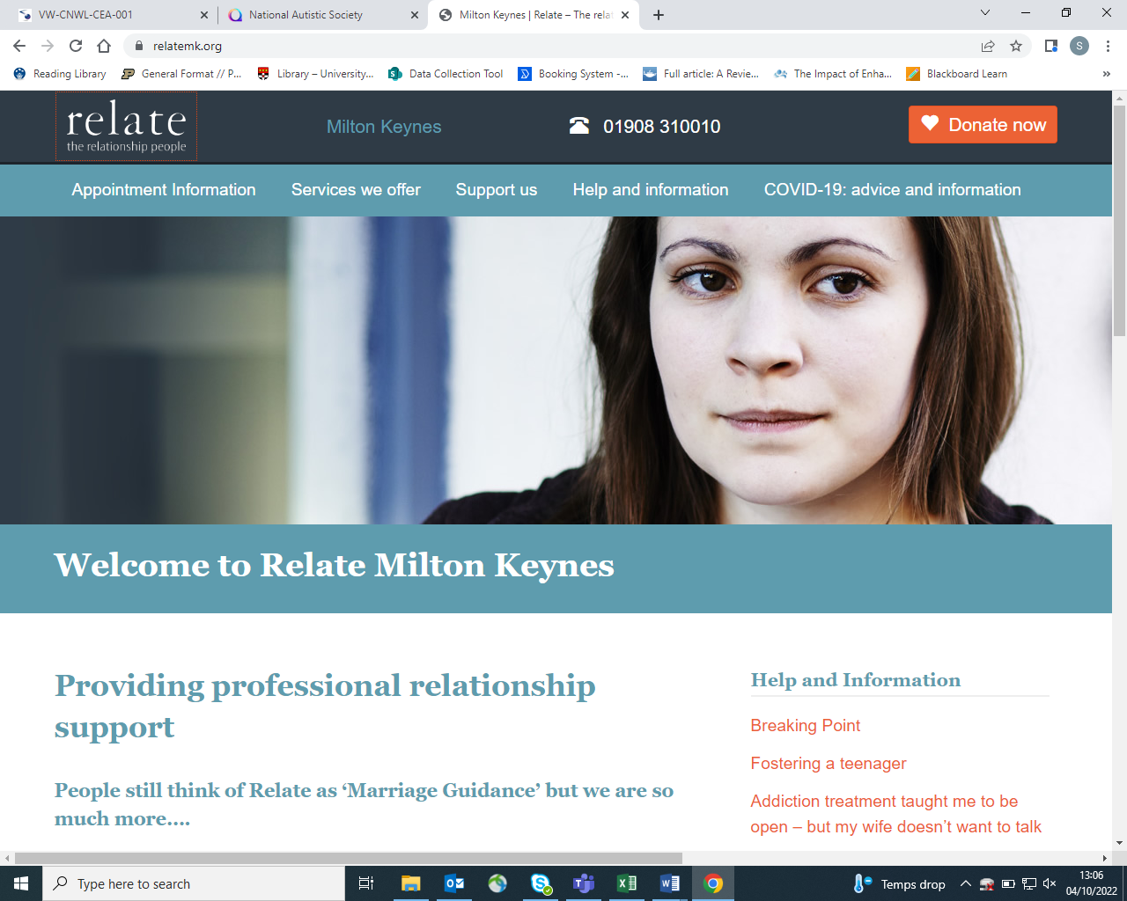

Relate MK - <https://relatemk.org/> Tel: 01908 310010

Family counselling and support. Helping couples, families and individuals to make relationships work better. Delivering inclusive, high-quality services that are relevant at every stage of life. Helping both the public and policy makers to improve their understanding of relationships and what makes them flourish.

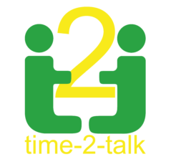

Time 2 Talk - <https://time-2-talk.co.uk/>

Online mental health resources, here to help promote mental health awareness and offer help to those suffering from depression and anxiety in all its forms.



Youth Access - [www.youthaccess.org.uk](http://www.youthaccess.org.uk)

Advice and counselling network for young people, including details of free local services.



Inter Action -http://www.interactionmk.org.uk/ Tel: 01908 318285

Community arts charity Inter-Action MK has been bringing arts to life in Milton Keynes for over 40 years. We use the arts to bring joy and purpose to all communities and especially to improve the life chances of people with support needs or disabilities or in challenging or vulnerable circumstances.



Child & Family Wellbeing <http://www.childandfamilywellbeing.co.uk/>

An affordable and quality service designed and built around modern children and their families. Based in Milton Keynes but work in Bucks, Beds and Northampton. F**rom therapeutic support to practical guidance.**

**Activities for parents to try at home that promote mental health and wellbeing:**

**Make a calm down jar**

This is a fun activity that is great for children’s mental health. They allow children to take a moment or two to manage their emotions, thoughts and feelings.

Here’s what you’ll need:

* an old water bottle or small juice bottle (preferably plastic)
* warm water
* glitter glue
* loose glitter

Here’s how to make them:

1. First, fill your bottle with warm water
2. Then add in some glitter glue
3. Next, add in some loose glitter

When your child needs a moment, have them shake it up to watch the glitter slowly float to the bottom. It is very soothing and relaxing to watch the glitter settle. Encourage them to do some deep breathing as they watch the glitter move throughout the bottle.

**Create a mood tracker**

With your child, design a mood tracker that they can write/draw/colour their emotions on from the day. This can encourage children to recognise how they are feeling and gives them an opportunity to talk it through with you.

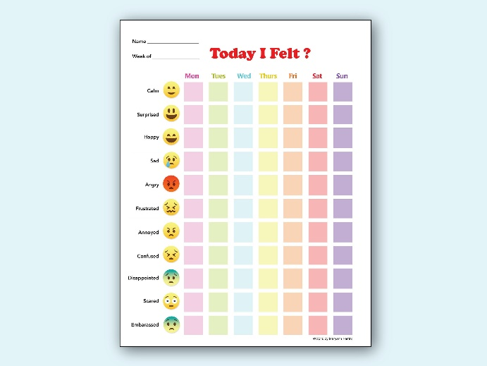You can design it however you want but here are some examples:

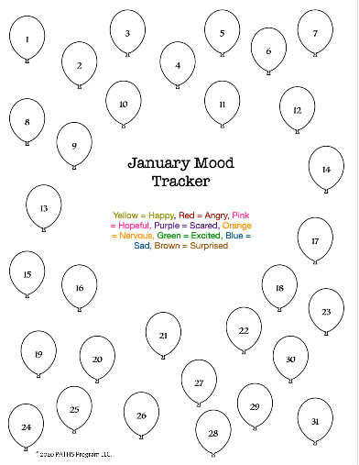

**Mindfulness**

Mindfulness allows children to be in the moment. It is a great tool for children to take a moment to relax, breathe, and understand their emotions. There are plenty of ways to practice mindfulness with your children, but here are some ideas:

1. **Teddy breathing** – get your children to lie down on the floor with a stuffed animal on their chest. Instruct them to breathe in deeply and watch their stuffy rise, then breathe out and watch it fall. See what happens when you breath slower or faster or hold your breath.
2. **Listening walk –** go out for a walk and ask your children to carefully listen to all the noises they can hear on their walk (e.g. cars, birds…). What do they notice? How does it make them feel?
3. **Colour game –** ask your child to find 5 things in a room in a certain colour
4. **Fly like an eagle**- Combine movement with deep breathing in this exercise. Ask your child to walk slowly around the room, they breathe in as their wings go up and breathe out as their wings go down.