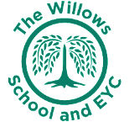
The Willows Grow |& Achieve Curriculum
~ Wellbeing ~
~ including RE, RSE, SEMH & Citizenship ~
You plant your tiny precious seeds with us …
Together We Nurture, Enrich & help them Grow to be the best they can be!
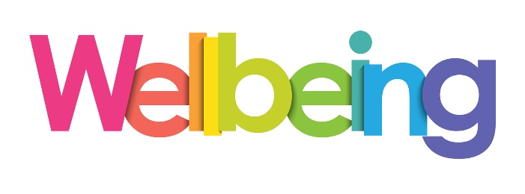
At The Willows School it is our intent that pupils wellbeing is crucial to their health and development. We aim to create a culture where children show a good understanding of their own emotions and mental health and promote good citizenship. We encourage children to talk about and share their wellbeing at different points of the day and empower children to seek support if they need it. Our school is a listening school where every voice is heard and listened to. Alongside healthy mental health children are taught key life skills such as resilience, perseverance and independence as part of a monthly focus and celebrated in a celebration assembly. In this school we are an inclusive community where all children (and adults) seek challenge, work to the best of their ability and develop a strong sense of self-confidence and positive wellbeing. These life skills enable children to lead safe, healthy, happy lives and they change and grow and equip them for the next stage in their school journey. As a school we believe it is important to support our children’s spiritual, moral, social and cultural development, we work hard to promote British values and believe that these are well embedded in all we say and do, including mutual respect and tolerance for those with different faiths and beliefs. The Willows School community is rich and diverse in culture and religion. We are a school who believe in the importance of learning about and learning from the different world religions. In today’s society it is vital to teach children about the traditions, festivals and values of others. We also encourage children to share their experiences of religion and celebrate their own beliefs. RE helps prepare pupils to become responsible citizens by raising local, national and global issues. We encourage the children to ask questions and show curiosity. We celebrate a wide range of festivals and celebrations with families and friends. Members of different faiths and religions are encouraged to share their knowledge to enhance learning within classes and the school.

Teaching and Learning of RSE/PSHE and Citizenship including SEMH at the Willows
Alongside a ‘Willows’ PSHE curriculum supported by Dimensions, which is personalised to meet the needs of our children, their families and which reflects and supports our local environment and wider community we ensure that our children have access to.
- Good quality first teaching that supports children’s wellbeing and mental health.
- Planned lessons which are age appropriate about relationships, how to keep ourselves safe, what is acceptable behavior towards others and how to tell someone if something is wrong.
- A restorative approach to managing daily life and solving problems.
- Available pastoral support for when children need it.
- Timetabled wellbeing interventions.
- Safe trusting relationships with key staff.
- Staff who are trained in various areas of mental health and a PSHE lead.
- Opportunism for learning beyond the classroom and access to specialist provision e.g music, arts and sports and the wider curriculum.
- A Computing curriculum which includes e-safety.
- Comprehensive safeguarding procedures.

In EYFS children will be developing knowledge and understanding, and appropriate vocabulary about, how to make relationships, share and take turns. Children will be given opportunities to take risks, work together, solve problems and learn how to keep themselves safe. Children will be supported to manage their own personal hygiene and learn about healthy food.

Teaching and Learning of RE at the Willows
We plan and follow the Milton Keynes agreed syllabus throughout the school alongside the National Curriulum for RE and specific experiences we provide to reflect our wider community.
In EYFS children will be developing knowledge and understanding, and appropriate vocabulary about, where they belong within their family and the wider community, different religions and the different ways of expressing and celebrating faiths. They will also be developing the following attitudes and skills:
• A sense of curiosity • Interest and enjoyment in discovery • Empathy and open-mindedness
• Commenting and asking questions • Expressing feelings and preferences

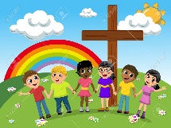
Children should begin to explore the world of religion in terms of religious figures, books, times, places and objects and by visiting places of worship. They should listen to and talk about stories. They may be introduced to religious words and use their senses in exploring religions and beliefs, practices and forms of expression. They reflect on their own feelings and experiences. They use their imagination and curiosity to develop their appreciation and wonder of the world in which they live. Every teacher of young children knows that knowledge is not fragmented in the early years, and all learning is holistic. Children learn in their own way through play, first hand experiences and people to make sense of the world.

Our religious focus in Key Stage 1 is Christianity, Judaism and Islam as a local faith, but we will always refer to other faiths where appropriate, particularly as we have many faiths in our school and local community. Pupils learn about different beliefs about God and the world around them and we support them to ask relevant questions and develop a sense of wonder about the world, using their imaginations. We encourage pupils to talk about what is important to them and others, to value themselves, reflect on their own feelings and experiences and develop a sense of belonging. We use the key aspects of RE over the three strands of ‘believing, behaving and belonging’ for pupils in Years 1 and 2.

We work hard to ensure that pupils are given the chance to experience as many of the following opportunities as possible:
• Visiting places of worship and focusing on symbols and feelings
• Listening and responding to visitors from local faith communities
• Using their senses and having times of quiet reflection
• Using art and design, music, dance and drama to develop their creative talents and imagination
• Sharing their own beliefs, ideas and values and talking about their feelings and experiences
• Beginning to use ICT to explore religions and beliefs as practised in the local and wider community.
