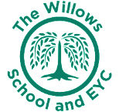
The Willows Grow |& Achieve Curriculum
~ Science~
You plant your tiny precious seeds with us …
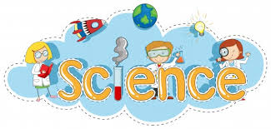
Together We Nurture, Enrich & help them Grow to be the best they can be!

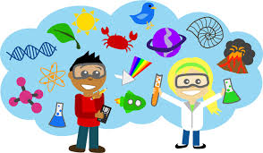
It is within our science curriculum that all children at The Willows have the opportunity to work scientifically, acquiring and applying prior knowledge and skills to ensure progress throughout each year group and over year groups. Children need to have been taught to ask simple questions and recognise that they can be answered in different ways. Use their own observations and ideas to suggest answers to questions and gather and record data to help answer questions. Also to have used scientific equipment correctly. To have performed simple tests and had opportunity to identify and classify.

Teaching and Learning of Science at the Willows:

Early Years (Nursery and Reception)
In the EYFS we follow the Early Years Foundation Stage curriculum and with relation to science the focus is on ‘Understanding the World’. Understanding the world develops as children take notice of everything around them including places and all the things within them such as trees in the natural environment and roads and traffic in the built environment. This awareness is extended by visiting places and finding out about different elements of environments in books, on television and through using other technology. This aspect also focuses on learning about cause and effect and is developed through having conversations with adults and other children about the things they observe. Opportunities are planned for the children to develop their knowledge and make links between their experiences.
KS1
The children follow the National Curriculum (2014) as well as focusing on the five areas of working scientifically: pattern seeking, observing over time, Identifying and classifying, fair testing and research. Within each academic year, children will study a range of scientific topics.
Science is taught as an integrated subject with lots of opportunity to teach across the curriculum using our Dimensions curriculum.

