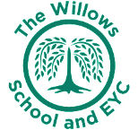
The Willows Grow |& Achieve Curriculum
~ Art ~
You plant your tiny precious seeds with us …
Together We Nurture, Enrich & help them Grow to be the best they can be!

Our Art Curriculum Intent

At The Willows School we believe that Art is a vital part of the education of all children. The child’s use and understanding of the visual language of Art needs to be developed by effective teaching and by a considered sequence of experiences. We aim to provide an Art curriculum which will enable each child to reach their full potential in learning in Art, through investigating and making, through research and the development of skills and through their evaluation of their own Art and that made by others.

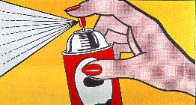

At The Willows we aim to ensure our children access an art curriculum not only through effective and creative day to day art lessons but also through whole art weeks where children of all ages work together in mixed ability and age groups. A whole school focus is agreed by all staff and planning ensures a diverse range of art skills are on offer during the week. We expose our children to global art work from a range of cultures and artists to ensure the diversity of our children is celebrated. We also use art as a focus for transition weeks. During these weeks, art work is produced as a legacy of children who prepare to move on to KS1 and KS2.

Art assessment is ongoing to inform teachers with their planning, lesson activities and differentiation. Art is monitored throughout all year groups using a variety of strategies. Evidence of artwork is on display throughout the school to implement a sense of pride for children’s artistic achievements. In Early Years a creative and inspiring environment includes a wide range of artwork to enhance indoor and outdoor areas. Children in Year 1 will begin to use a sketch book in the Summer Term, as evidence of art skills completed through cross curricular topic work. In Year 2 they will continue and complete the sketchbook as evidence of progression of art skills. Children are able to talk about the work of artists from a range of art movements, historically, globally and culturally diverse and give a well-informed opinion of their work.

Teaching and Learning of Art at the Willows:
The aims of both the EYFS and National Curriculum are fully embedded in all aspects of our Art and wider Curriculum. The teaching of Art covers the following areas:
Early Years  Nursery & Reception | Key Stage One  Year One and Year Two
Creating with materials  Being Imaginative and Expressive | • to use a range of materials creatively to design and make products  • to use drawing, painting and sculpture to develop and share their ideas, experiences and imagination  • to develop a wide range of art and design techniques in using colour, pattern, texture, line, shape, form and space  • about the work of a range of artists, craft makers and designers, describing the differences and similarities between different practices and disciplines, and making links to their own work.

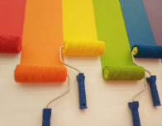

EYFS

Art is encompassed and taught under the banner of ‘Expressive Art and Design’ within the EYFS curriculum. Children are taught art appreciation through a play-based curriculum and have the opportunity to experience a wide range of materials, tools and techniques to begin to develop their skills in this area. Skilled Early Years practitioners set up creative continuous provision to ensure a wide range of art activities are on offer and skills are continually assessed to ensure maximum participation and progression from the children.
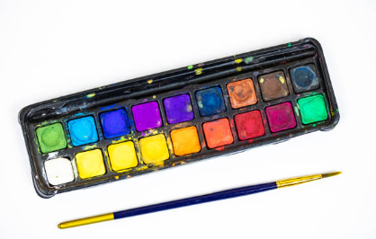

Key stage 1

Art, craft and design embody some of the highest forms of human creativity. A high-quality art and design education will engage, inspire and challenge pupils, equipping them with the knowledge and skills to experiment, invent and create their own works of art, craft and design. As our pupils progress, we encourage them to think critically and develop a more rigorous understanding of art and design. We teach them the knowledge of how art and design both reflect and shape our history, and contribute to the culture, creativity and wealth of our nation and globally.

