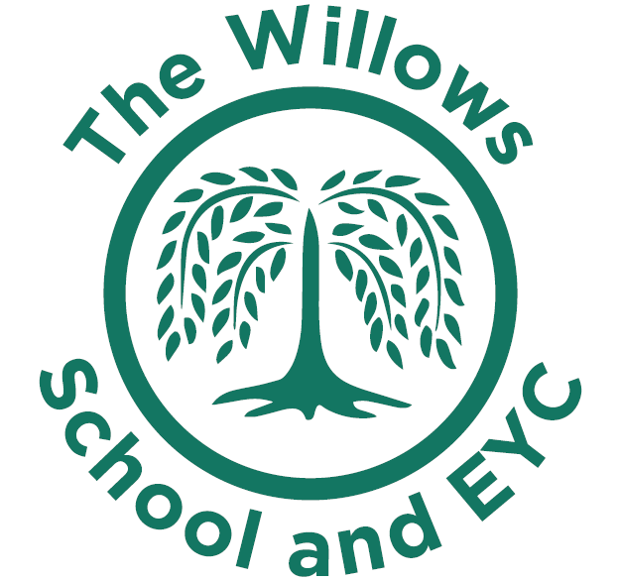

Remote Learning at The Willows and EYC

Overview
If a child is off school for a significant amount of time the school will make contact and provide home learning if this is appropriate. The learning maybe in the form of a paper pack, via an online platform or a member of staff visiting the pupil.
For all home learning we will ensure that the pupils have the correct resources at home to complete the tasks.
Below are some web links you may wish to use to support your child’s learning at home.

SUBJECT | WEB LINK | DETAIL
Maths | https://www.bbc.co.uk/cbeebies/shows/numberblocks  https://www.ictgames.com/  https://www.bbc.co.uk/bitesize | Children can play games and interact whilst learning about different subjects as well as maths.
Reading | https://home.oxfordowl.co.uk/reading/free-ebooks/  https://collins.co.uk/pages/big-cat-ebooks | Children are to read from their own reading book or download and read a free e-book from Oxford Owls or Collins Big Cat.
Writing incl. Spelling/Phonics | https://www.phonicsplay.co.uk/ | Ask your child’s teacher what phase they learning and play some fun learning games
Curriculum subjects | https://www.bbc.co.uk/bitesize/this-terms-topics  https://classroom.thenational.academy/ | BBC Bitesize and the Oak Academy contain a range of different subjects.
Other useful websites | https://www.bedtimeshortstories.com/  https://www.bbc.co.uk/iplayer/episodes/b00jdlm2/cbeebies-bedtime-stories | Can be watched and listened to anytime of the day

BBC Bitesize
Bitesize Daily has been developed by the BBC to provide new lessons every weekday for pupils in year 1 to year 10. Created in collaboration with teachers and educational experts, its videos and interactive activities cover core subjects and other topics on the school curriculum.

Oak National Academy
The ‘teaching content’ will be provided to children through age appropriate video content on the DfE published list of educational resources site; from Oak National Academy. In their ‘classroom’ each lesson is an hour-long. They’re delivered by a practising teacher, with a pre-recorded video as well as quizzes, worksheets and creative activities. It’s all easy to use, there’s no login or password, and you can access the lessons on any device- pupils only need materials they can find at home.

Other resources
We may use recorded video to provide weekly information, instructional videos and assemblies, depending on the level of absenteeism throughout the school.

Providing feedback
Pupils or their parents can send any completed work/photographs to teachers via Tapestry. Work will receive an acknowledgement from a teacher or other school staff. This will not aim to replicate feedback on strengths and development in learning that parents might expect when a child is attending school.

Contact with pupils/ parents
Parents are able to contact the school via telephone or the school office email address. Where a pupil is self-isolating on medical ground for a significant period of time, contact will be made via telephone on a weekly basis to monitor learning and provide support if needed.

